Assignment 1
Chapter 1

Question - 1:
What do you understand by “Performance Via Prediction” in terms of computer architecture? Give a proper example of it.

Question - 2:
Why is it important to keep redundancy while designing a system? Explain a scenario where this redundancy will be useful.

Question - 3:
- Explain Amdahl’s Law in your own words.
- Can you relate/connect Amdahl’s law with any of the design principles, mentioned below? Explain the reason with an example.

 | Design Principle
1 | Performance via Prediction
2 | Performance via Pipelining
3 | Make the common case faster
4 | Use Abstraction to Simplify Design

Question - 4:
Narrate a scenario where increasing the throughput could also improve the response time. Justify your answer.

Question - 5:
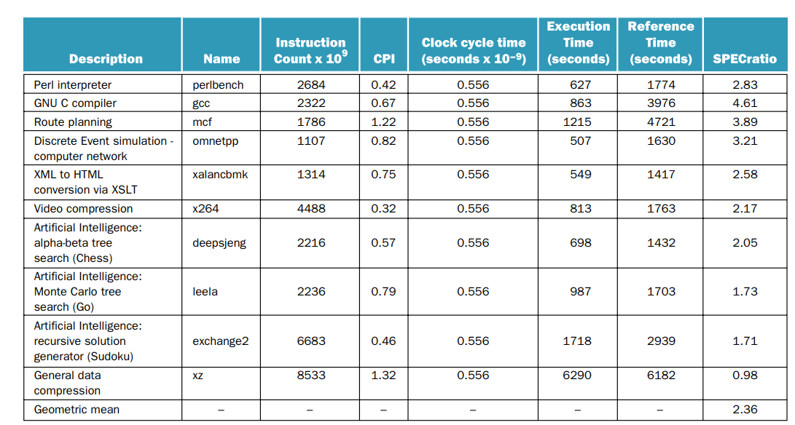
To calculate the benchmark of a system, why do we take the geometric mean instead of only taking the average of the individual spec ratios?

Question - 6:
In the context of evaluating CPU performance, three key factors are considered:
- Instruction Count
- CPI (Cycles Per Instruction)
- Clock Rate

Which of these factors are affected by the choice of programming language, and in what way?

